PYTHON CODE OUTPUT SCRENNSHOTS

Step 1: Launching the WOA Ransomware Detection System
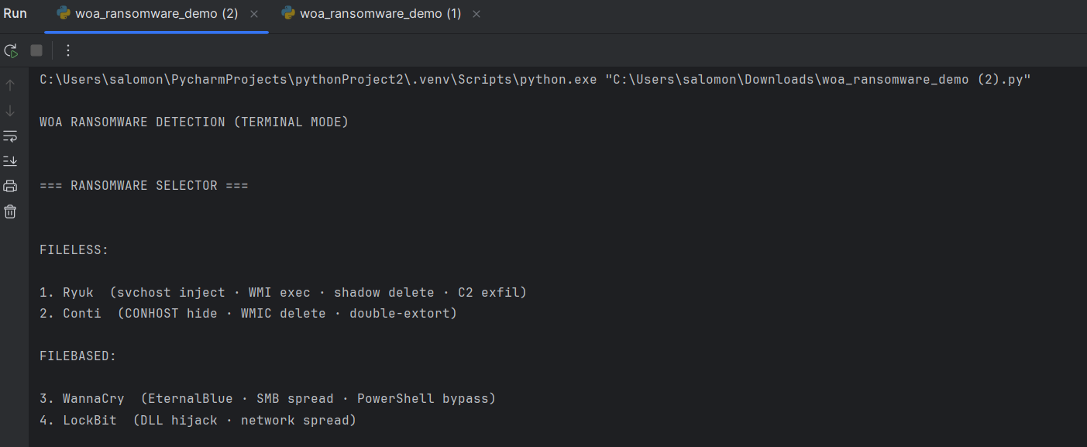

Step 2: User Input for Ransomware Selection
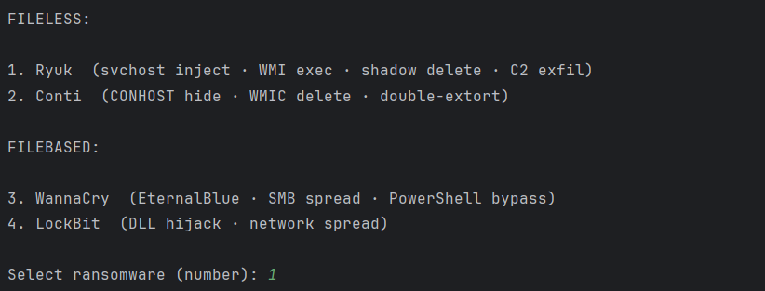

Step 3: Initialization of Memory Analysis and Feature Extraction
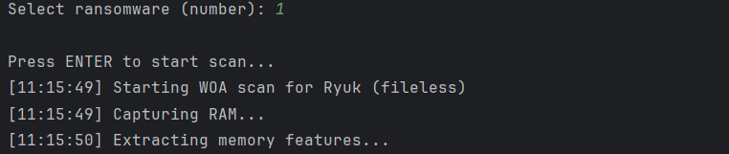

Step 4: Whale Optimization Algorithm (WOA) Feature Selection Process
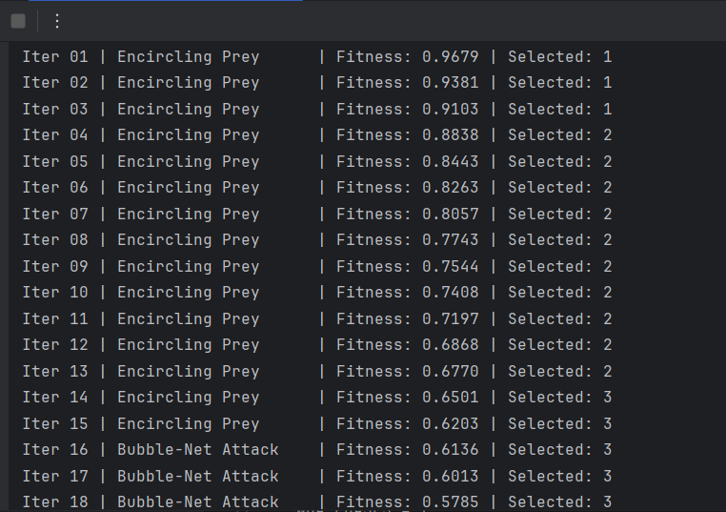

Step 5: Final Detection Output and Accuracy Results
